Clone repository and start work

1. Sign in with your Bit bucket account
2. Sign in to your gmail account and accept the invitation of joining the team (If no invitation is present in your inbox request the admin to add you in the team)
3. Go to Teams and select your team

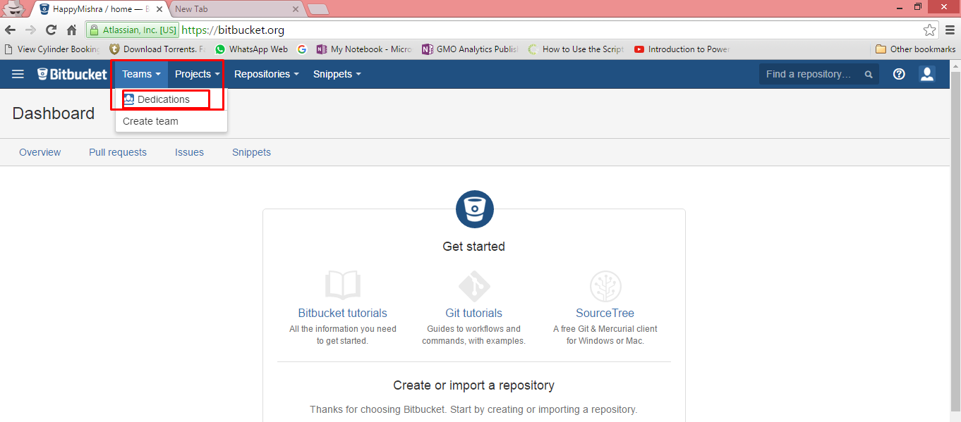

1. Select the repository

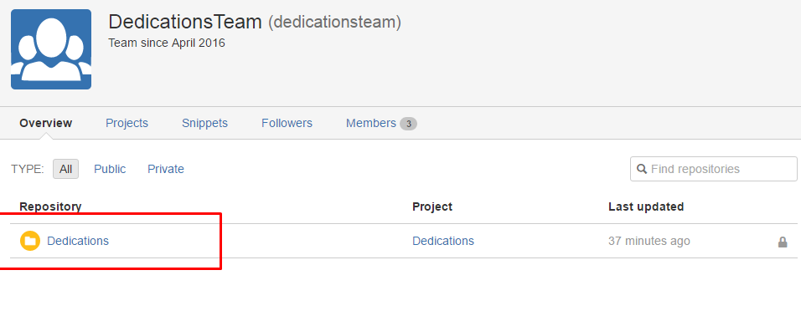

1. To clone the repository, click on clone and select Clone in Source Tree

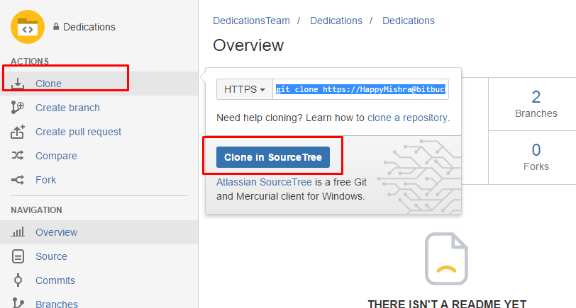

1. Enter login name and password of the Bit bucket account

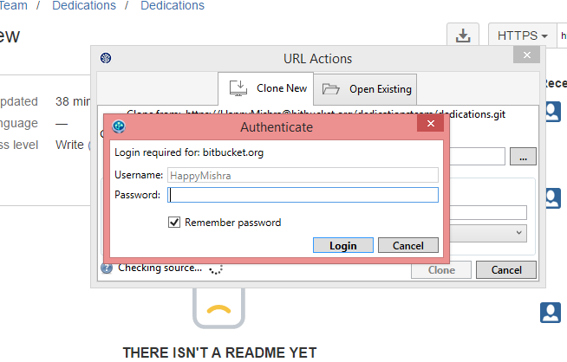

1. Select the folder where you want to clone the repository

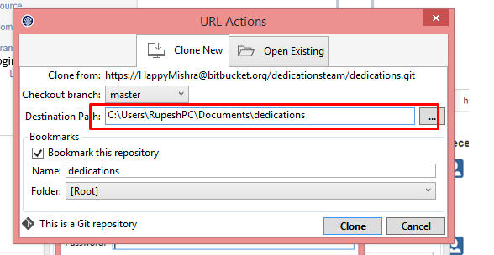

1. Go to your bit bucket account, create your own branch from test and start working.